BNetzA IT-Sicherheitskatalog Compliance for Log360
Tagline: Support Germany’s energy sector IT security compliance with centralized monitoring from Log360.

Overview
The BNetzA IT-Sicherheitskatalog Compliance extension for Log360 helps German energy network operators meet the Federal Network Agency's IT Security Catalogue requirements for critical energy infrastructure.
Log360 collects and correlates logs from energy management systems, SCADA environments, IT infrastructure, and network devices, providing security teams with continuous visibility into cybersecurity events affecting grid operations. Compliance teams can document ISMS control implementation and generate audit evidence for BNetzA submissions.

Key Features
- Generate BNetzA IT-Sicherheitskatalog-aligned audit reports covering ISMS controls including access management, network monitoring, and incident detection for energy systems.
- Monitor operational technology environments and IT systems for unauthorized access, configuration changes, and anomalies that may impact energy supply operations.
- Configure real-time alerts for security events relevant to energy KRITIS obligations such as SCADA access violations and critical infrastructure intrusion indicators.
- Export compliance documentation in PDF and CSV formats for BNetzA auditor submissions and internal energy sector ISMS governance.
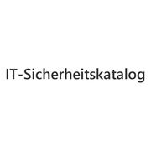
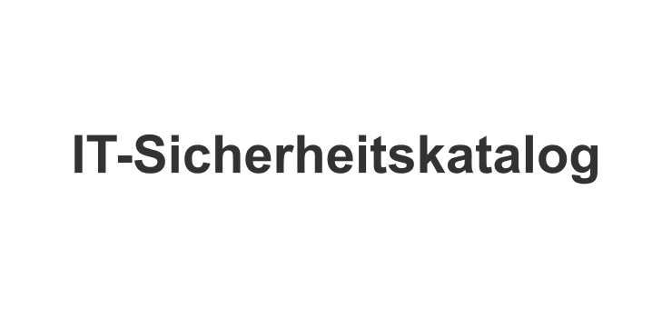

Screenshots
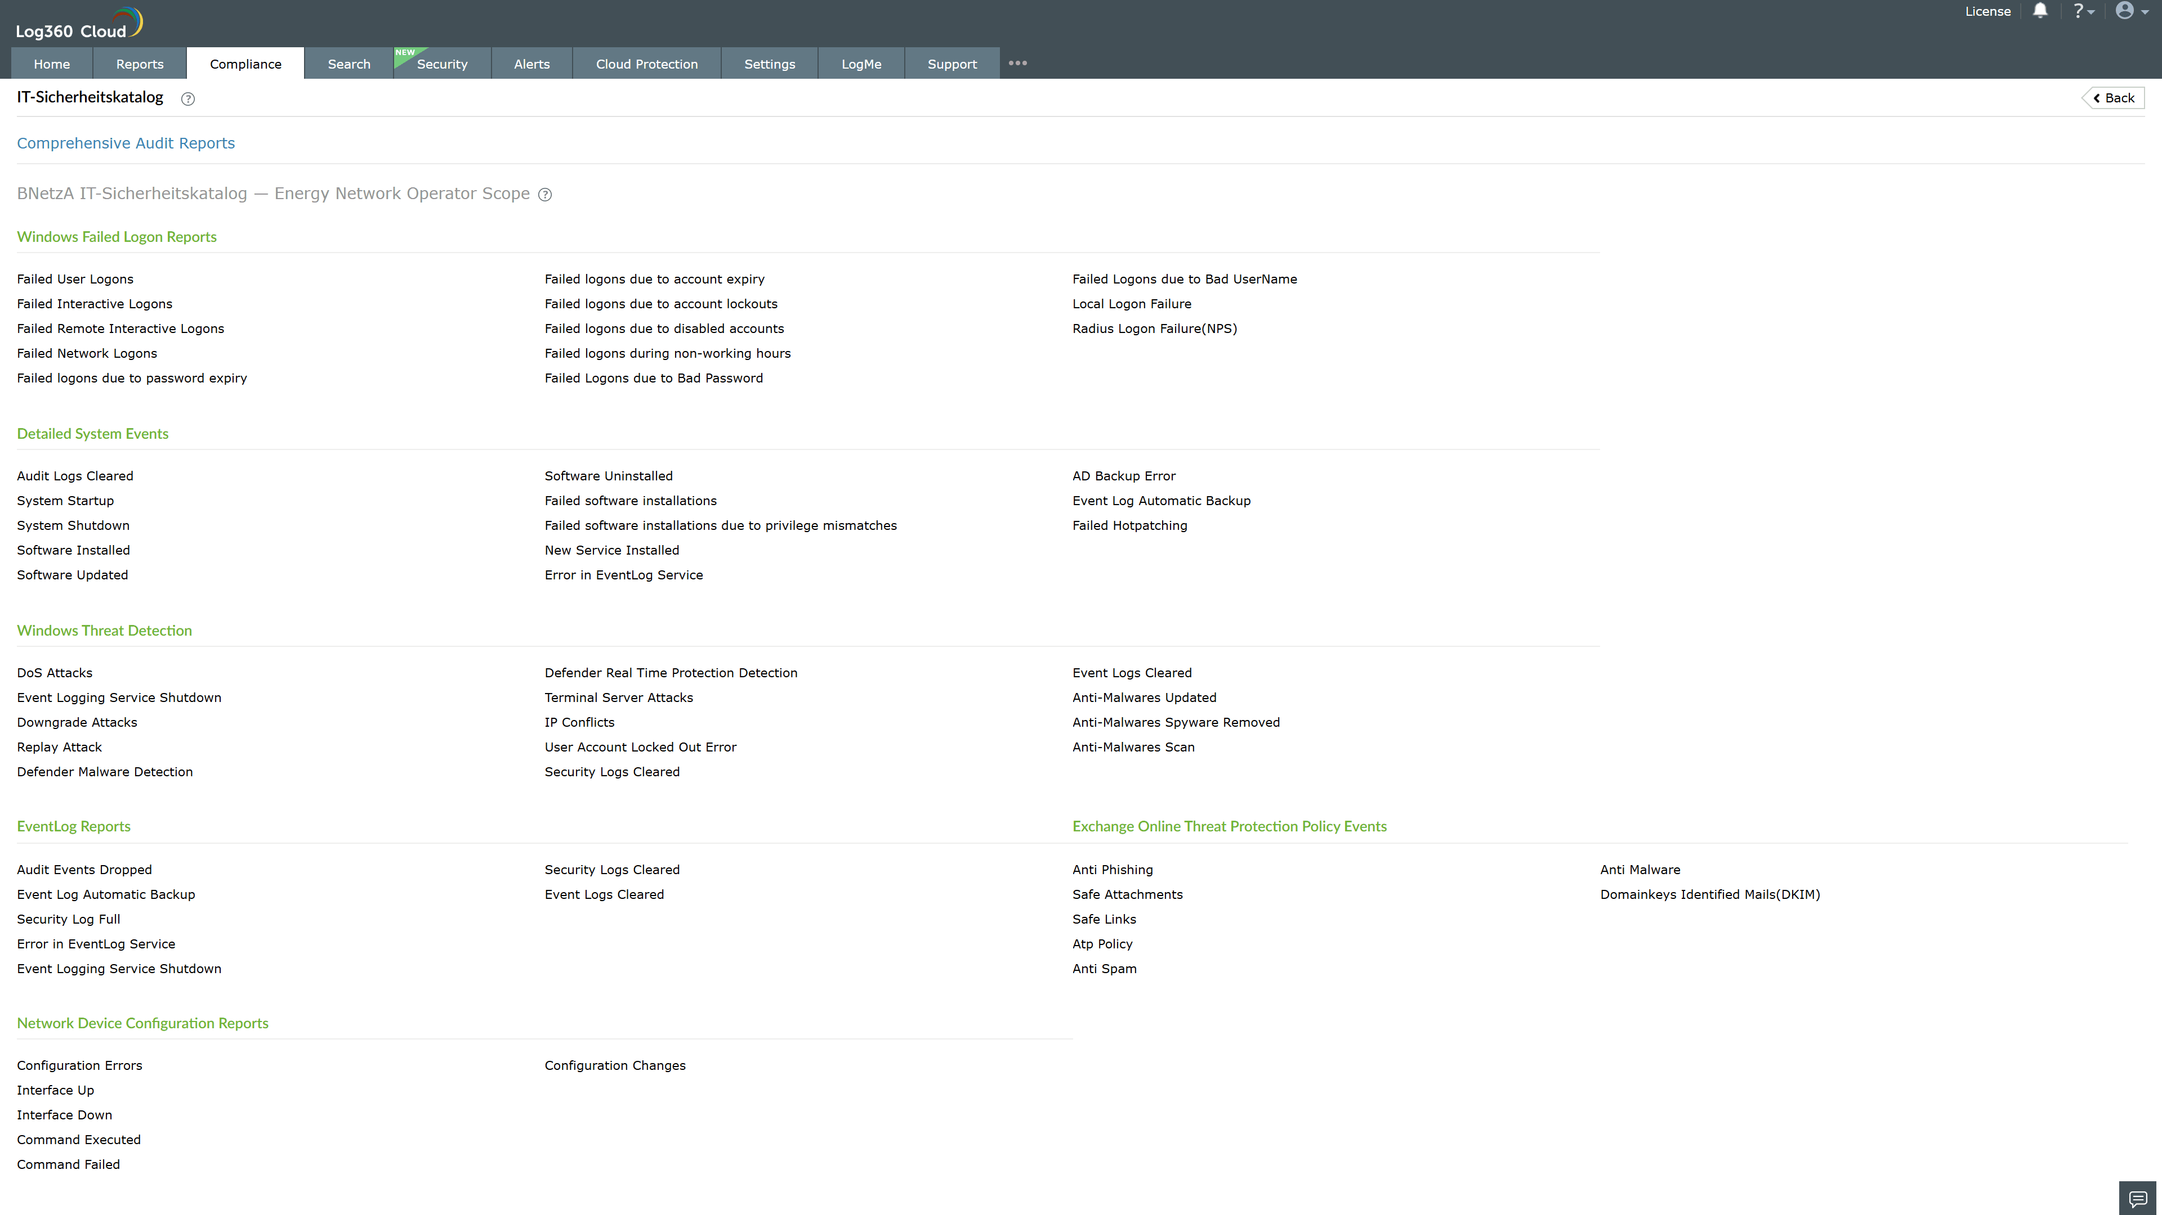
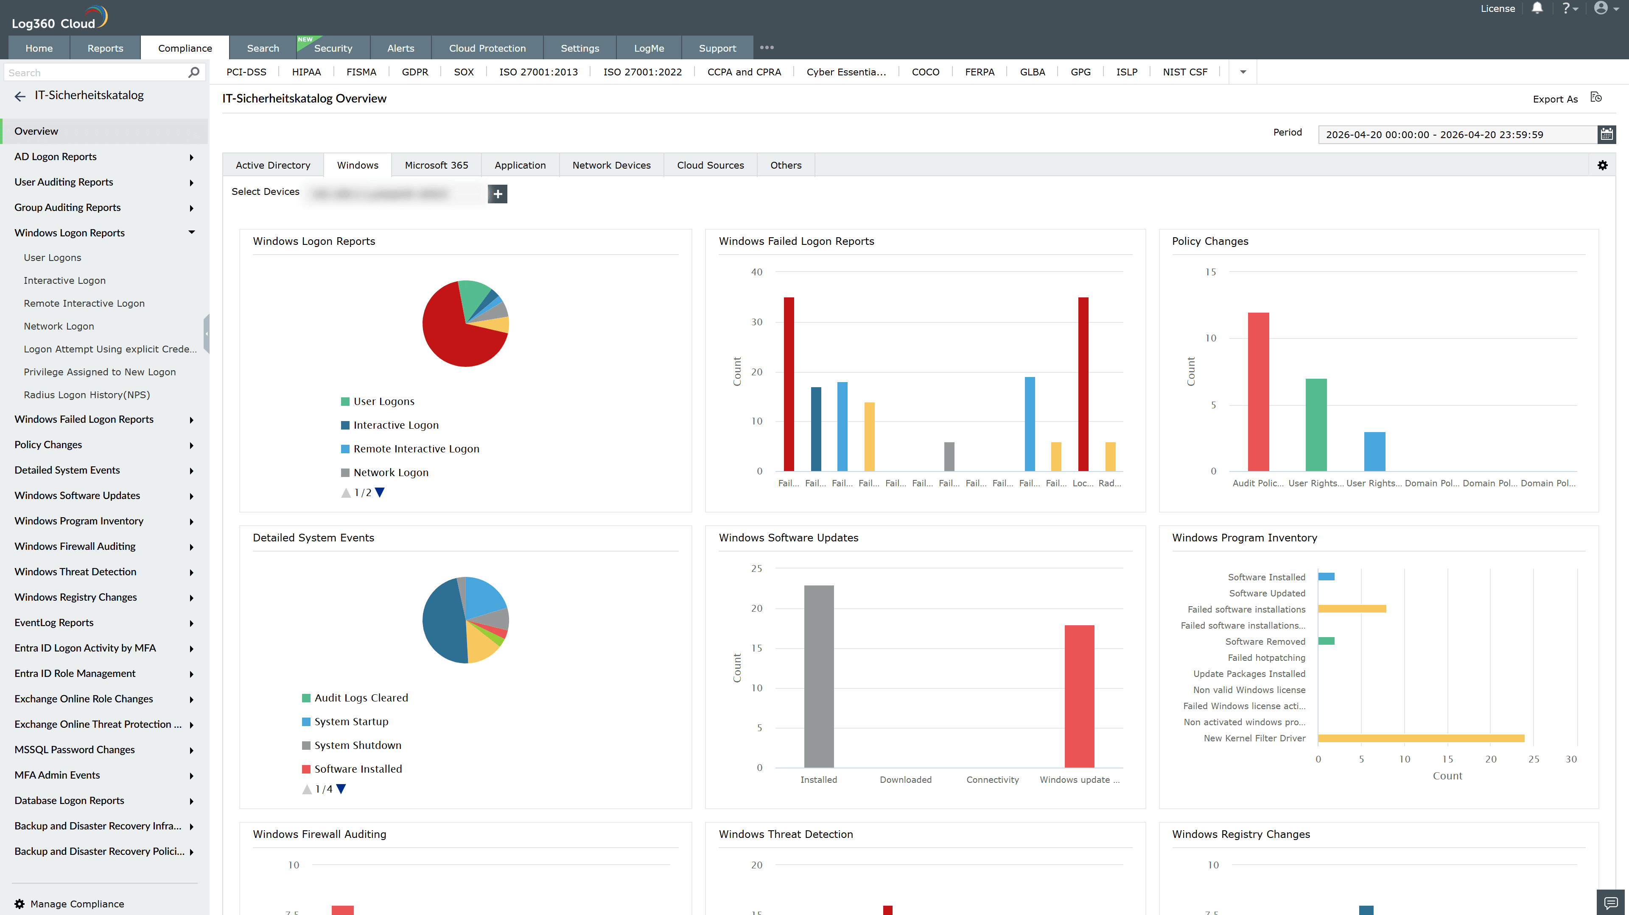
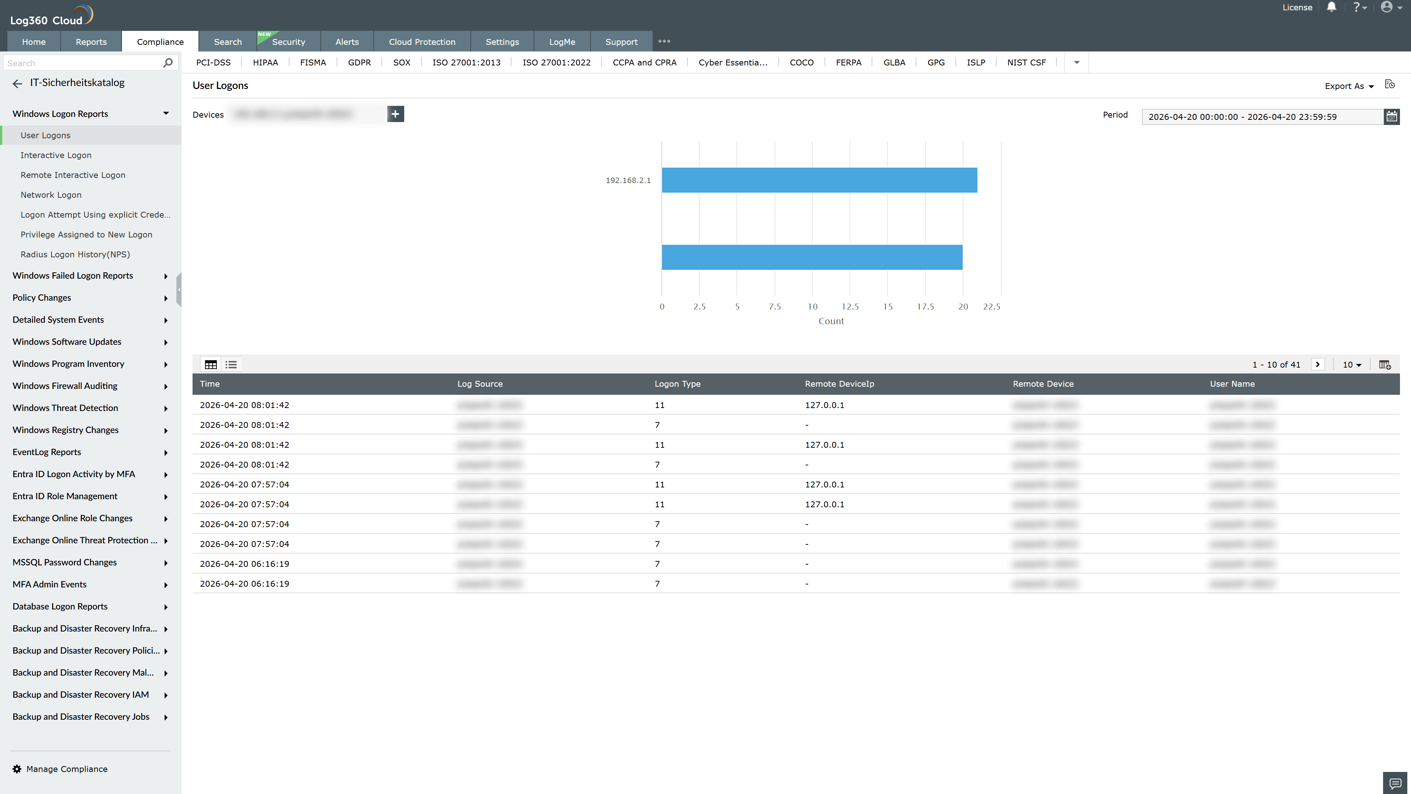
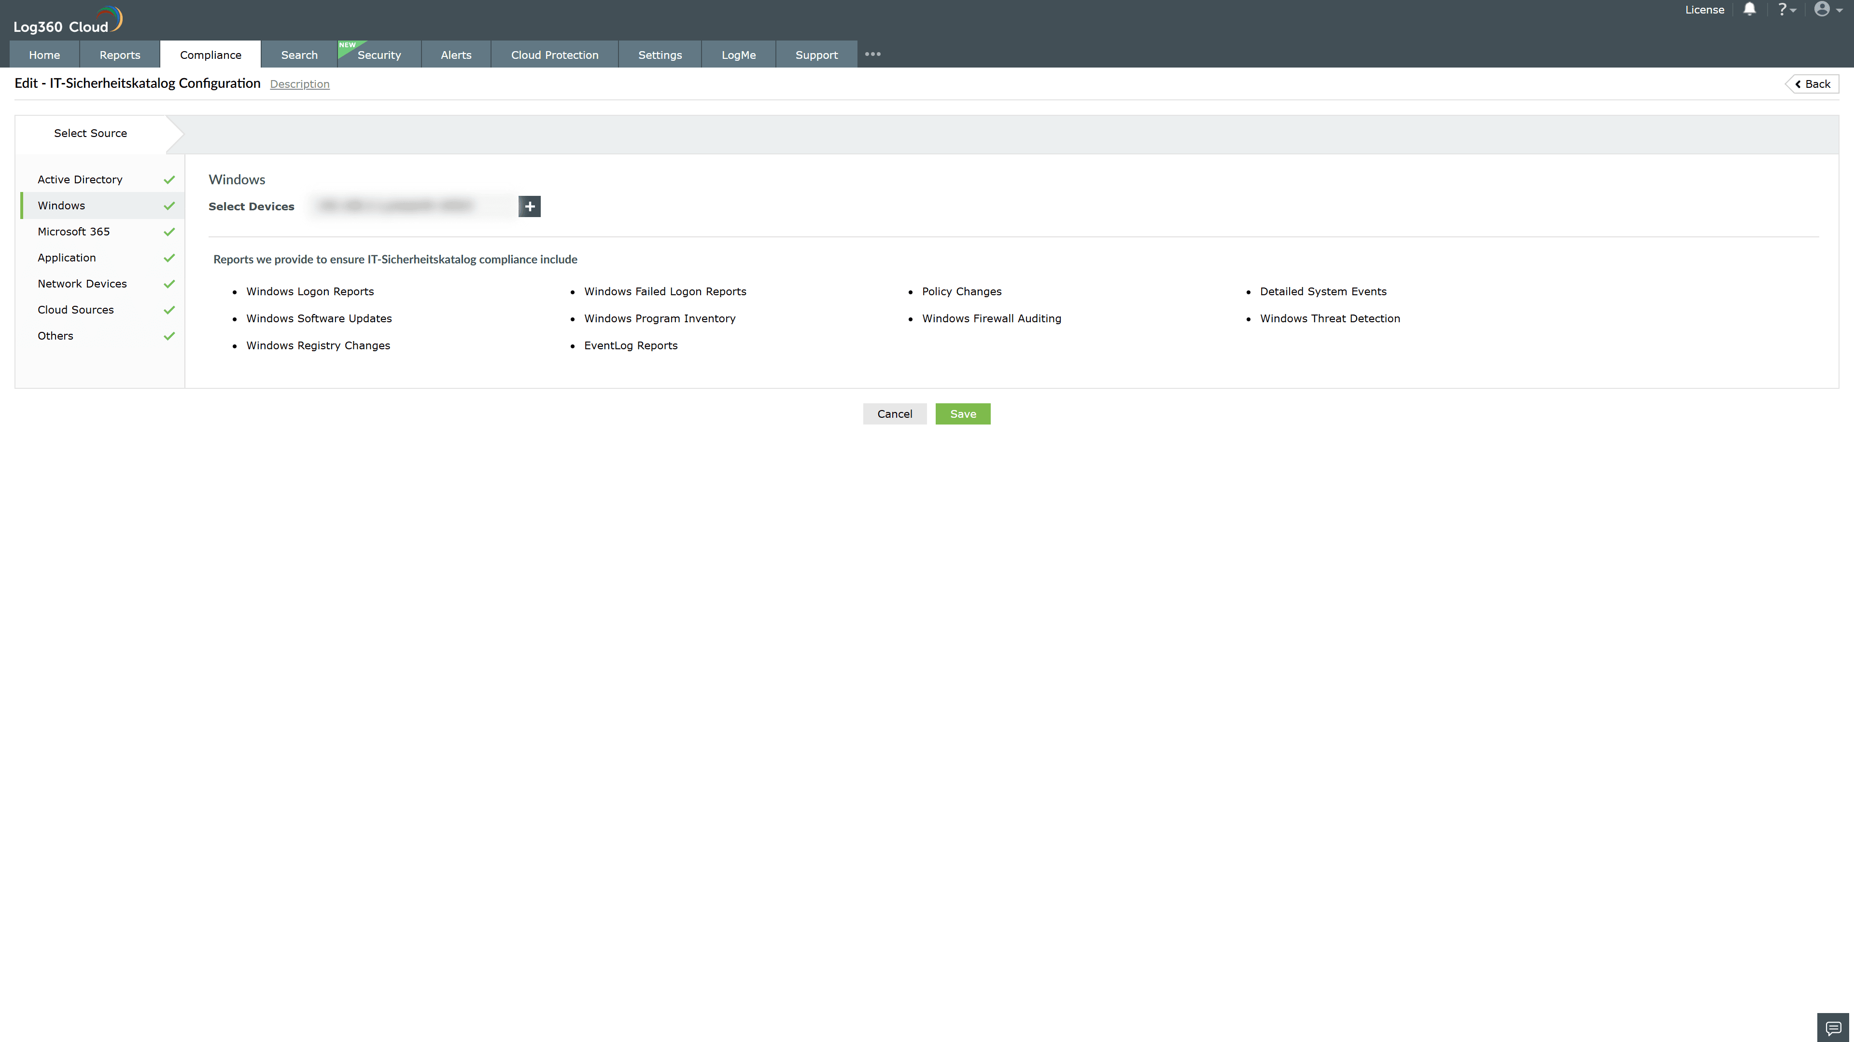

Valid Submission : Yes
Supported Editions : Free, Basic, Standard, Professional, MSSP
Help Document : https://www.manageengine.com/log-management/help/integrations/compliance-extensions.html
Help Video : Not provided
Tags : Log360, Compliance, Privacy monitoring, Data privacy, Regulatory compliance
Supported DCs : US, IN, JP, CA, AU, UK and EU
Privacy Policy:
Terms of Service:
Release Notes:
Predefined reports for the BNetzA IT-Sicherheitskatalog Compliance

